How to Install the ESP8266 Board in Arduino IDE

141 Shares

There are a variety of development environments that can be used to program the ESP8266. The ESP8266 community created an add-on for the Arduino IDE that allows you to program the ESP8266 using the Arduino IDE and its programming language.  
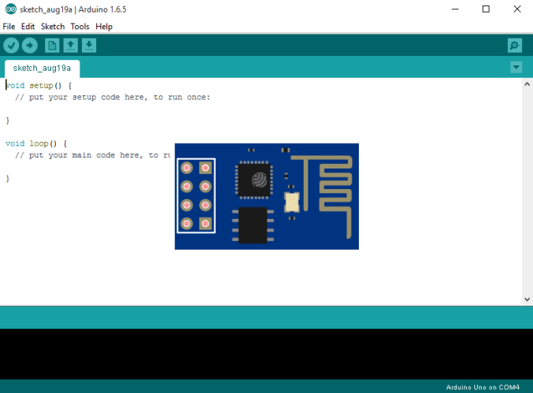

Before continue reading this tutorial, please read the following blog post to learn more about this WiFi module: [How to get started with the ESP8266](http://randomnerdtutorials.com/getting-started-with-esp8266-wifi-transceiver-review/).

If you like the ESP and you want to do more projects you can read my eBook [Home Automation using ESP8266 here](http://randomnerdtutorials.com/home-automation-using-esp8266/).

**Let’s get started!**

Downloading Arduino IDE

**RECOMMENDED:** [Read our Home Automation using ESP8266 Course](http://randomnerdtutorials.com/home-automation-using-esp8266-r/)

First download the Arduino IDE to ensure that you have the latest software version (some older versions won’t work), visit the following URL: <https://www.arduino.cc/en/Main/Software>.

Then select your operating system and download the latest software release of the Arduino IDE.

Installing Arduino IDE

Grab the file that you have just downloaded and open the Arduino IDE application file (see Figure below).

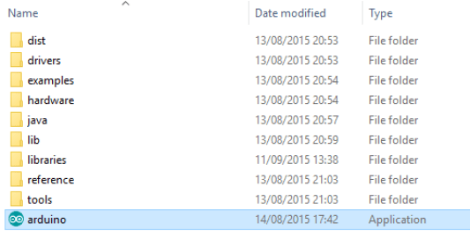

When the Arduino IDE first opens, this is what you should see:

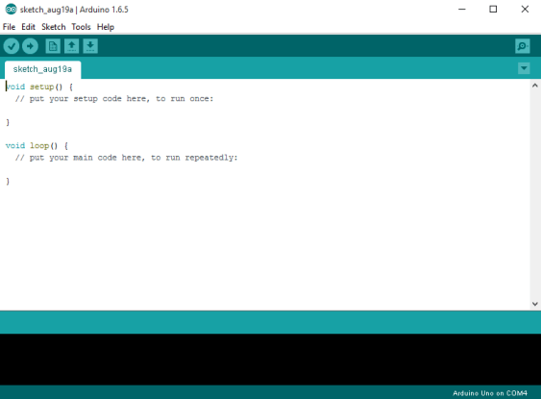

**DOWNLOAD FREE PDF:** Arduino eBook with 18+ Projects

Installing the ESP8266 Board

To install the ESP8266 board in your Arduino IDE, follow these next instructions:

**1)** Open the preferences window from the Arduino IDE. Go to File > Preferences

**2)** Enter http://arduino.esp8266.com/stable/package_esp8266com_index.json into the “Additional Board Manager URLs” field as shown in the figure below. Then, click the “OK” button.

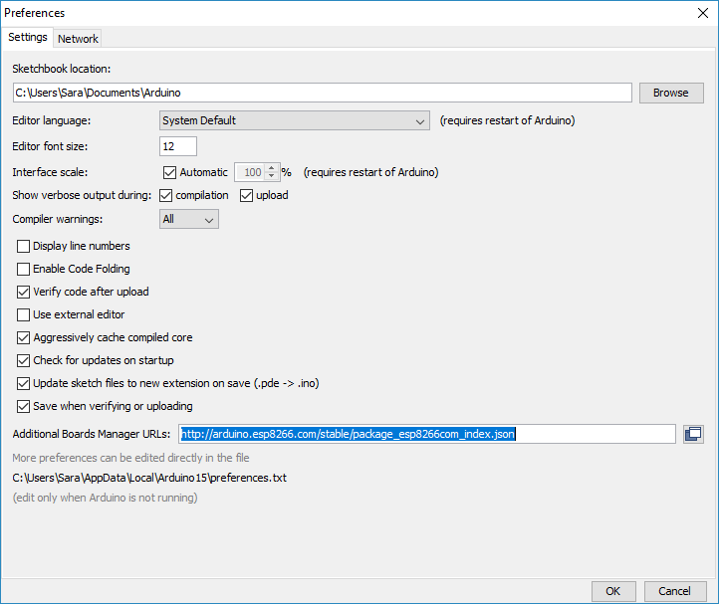

**3)** Open boards manager. Go to Tools > Board > Boards Manager…

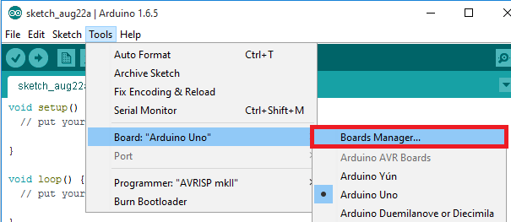

**4)** Scroll down, select the ESP8266 board menu and install “esp8266 platform”

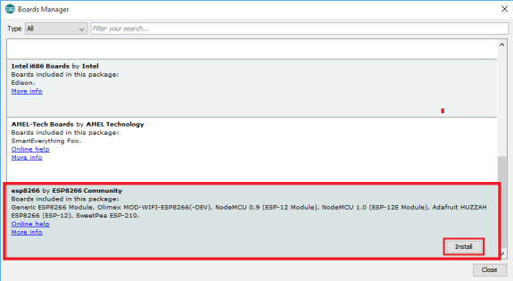

**5)** Choose your ESP8266 board from Tools > Board > Generic ESP8266 Module

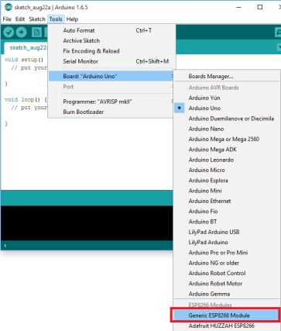

**6)** Finally, re-open your Arduino IDE

Testing the Installation

To test the ESP8266 add-on installation, let’s see if we can blink an LED with the ESP8266 using the Arduino programming language.

**Parts List:**

Here’s the hardware that you need to complete this project:

* [ESP8266](https://makeradvisor.com/tools/esp8266-esp-12e-nodemcu-wi-fi-development-board/) – read [Best ESP8266 Wi-Fi Development Boards](https://makeradvisor.com/best-esp8266-wi-fi-development-board/)
* [1x LED](https://makeradvisor.com/tools/3mm-5mm-leds-kit-storage-box/)
* [330 Ohm resistor](https://makeradvisor.com/tools/resistors-kits/) (220 Ohm or other values also work)
* [Breadboard](https://makeradvisor.com/tools/mb-102-solderless-breadboard-830-points/)
* [Jumper wires](https://makeradvisor.com/tools/jumper-wires-kit-120-pieces/)

If you’re using an [ESP8266-01](https://makeradvisor.com/tools/esp-01-wi-fi-board/), you need an [FTDI programmer](https://makeradvisor.com/tools/ftdi-programmer-board/) to upload code.

You can use the preceding links or go directly to [MakerAdvisor.com/tools](https://makeradvisor.com/tools/?utm_source=rnt&utm_medium=post&utm_campaign=post) to find all the parts for your projects at the best price!

Uploading the Sketch

**Uploading the Sketch to the ESP-12E**

If you’re using an ESP-12E NodeMCU Kit, uploading the sketch is very simple, since it has built-in programmer. Plug your board to your computer. Make sure you have the right board and COM port selected.

Then, copy the code provided, and click the “Upload” button in the Arduino IDE and wait a few seconds until you see the message “Done uploading.” in the bottom left corner.

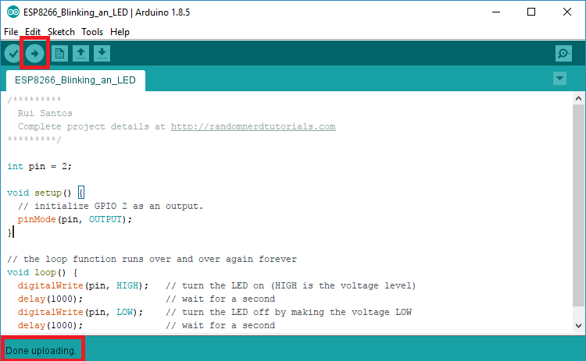

**Uploading the Sketch to the ESP-01**

Uploading code to the ESP-01 requires establishing a serial communication between your ESP8266 and a FTDI Programmer as shown in the schematic diagram below.

[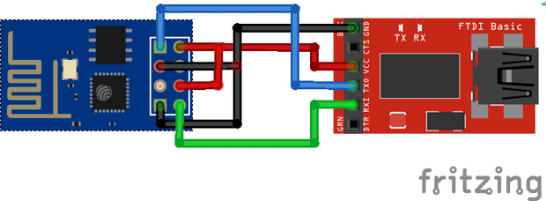](https://i1.wp.com/randomnerdtutorials.com/wp-content/uploads/2015/02/ESP8266-Flasher.png)

The following table shows the connections you need to make between the ESP8266 and the FTDI programmer.

|  |  |
| --- | --- |
| **ESP8266** | **FTDI programmer** |
| RX | TX |
| TX | RX |
| CH_PD | 3.3V |
| GPIO 0 | GND |
| VCC | 3.3V |
| GND | GND |

If you have a brand new FTDI Programmer and you need to install your FTDI drivers on Windows PC, visit this website for the official drivers: <http://www.ftdichip.com/Drivers/VCP.htm>. Alternatively, you can contact  
the seller that sold you the FTDI Programmer.

Then, you just need to connect the FTDI programmer to your computer, and upload the sketch to your ESP. You should see “Done Uploading” after a few seconds.

Code

Here’s the code you should upload to your ESP8266.

/*********  
  Rui Santos  
  Complete project details at http://randomnerdtutorials.com    
*********/  
  
int pin = 2;  
  
void setup() {  
  // initialize GPIO 2 as an output.  
  pinMode(pin, OUTPUT);  
}  
  
// the loop function runs over and over again forever  
void loop() {  
  digitalWrite(pin, HIGH);   // turn the LED on (HIGH is the voltage level)  
  delay(1000);               // wait for a second  
  digitalWrite(pin, LOW);    // turn the LED off by making the voltage LOW  
  delay(1000);               // wait for a second  
}

[view raw](https://github.com/RuiSantosdotme/Random-Nerd-Tutorials/raw/master/Projects/blink_led_esp8266.ino)[Projects/blink_led_esp8266.ino](https://github.com/RuiSantosdotme/Random-Nerd-Tutorials/blob/master/Projects/blink_led_esp8266.ino)

**Note:** You have to select your FTDI’s port number under the **Tools** > **Port** menu of the Arduino IDE.

Schematic

**If you’re using an ESP8266-12E**

Connect an LED to your ESP8266, as shown in the following schematic diagram. The LED should be connected to GPIO 2 (D4 marked on the silkscreen).

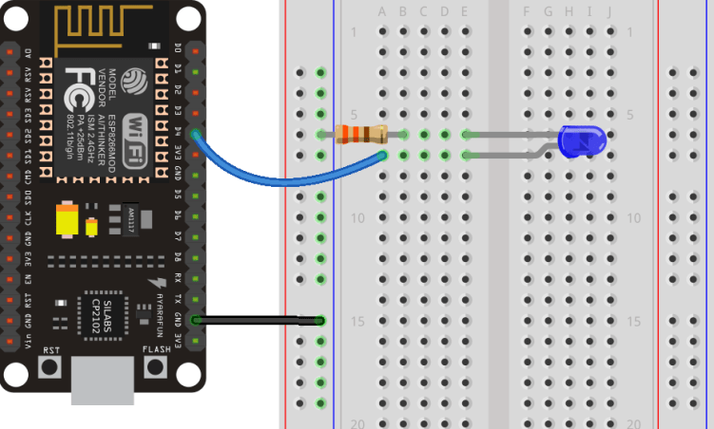

**If you’re using an ESP8266-01**

If you’re using the ESP8266-01 assemble the following circuit.

[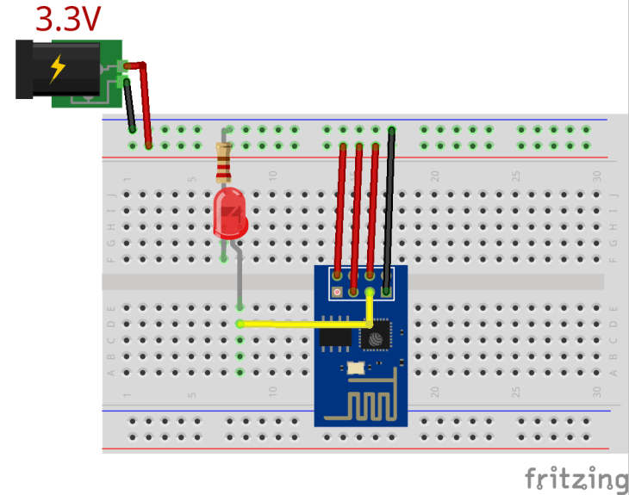](https://i0.wp.com/randomnerdtutorials.com/wp-content/uploads/2015/09/ESP8266-Blinking-an-LED.png)

If everything went well, your LED should be blinking every 1 second.